**TASK 3.2P**

Screenshot of the code:

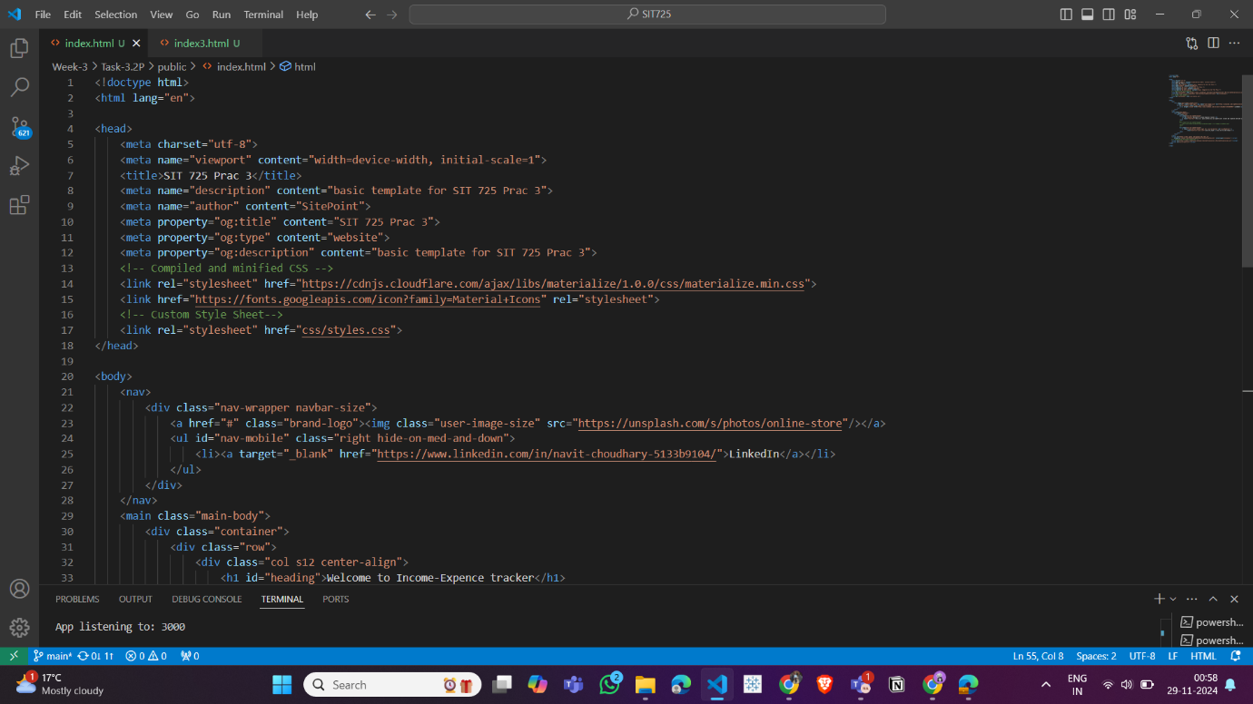

Screenshot of the terminal:

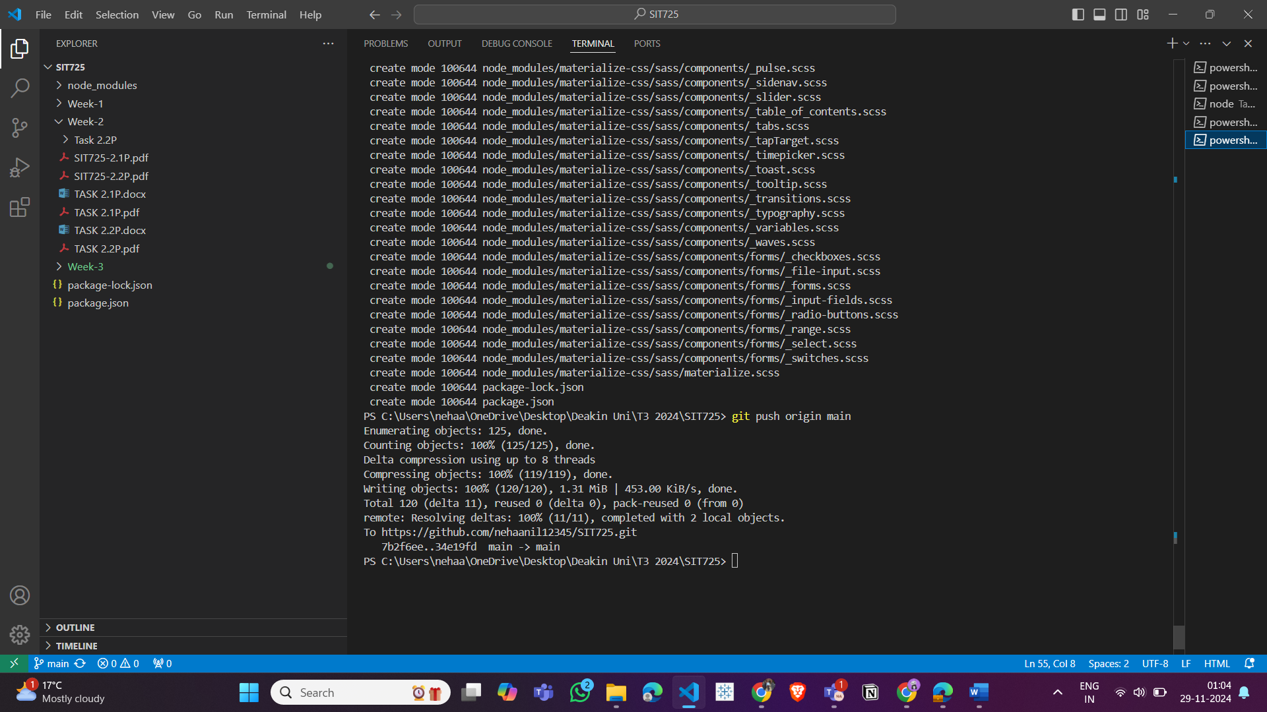

GitHub repo link: <https://github.com/nehaanil12345/SIT725.git>